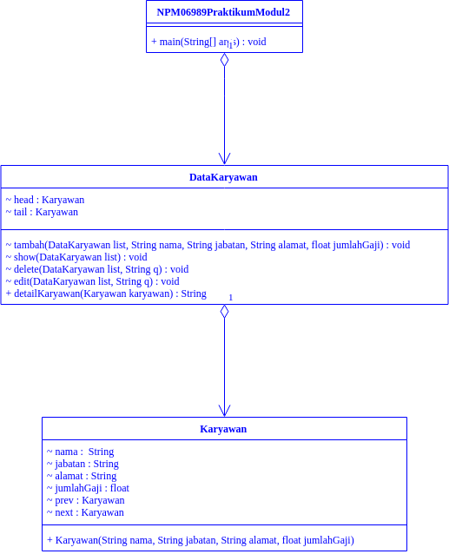

Keterangan Source Code :

--------------------------------------------------------------------------------------------------------------------------------------------------------------------------------------------------------------------------------------------------------------------------------------------------------------------------------------------------------------------------------------------------------------------------------------------------------------------------------------------------------------------------------------------------------------------------------------------------------------------------------------------------------------------------------------------------------------------------------------------------------------------------------------------------------------------------------------------------------------------------------------------------------------------------------------------------------------------------------------------------------------------------------------------------------------------------------------------------------------------------------------------------------------------------------------------------------------------------------------------------------------------------------------------------------------------------------------------------------------------------------------------------------------------------------------------------------------------------------------------------------------------------------------------------------------------------------------------------------------------------------------------------------------------------------------------------------------------------------------------------------------------------------------------------------------------------------------------------------------------------------------------------------------------------------------------------------------------------------------------------------------------------------------------------------------------------------------------------------------------------------------------------------------------------------------------------------------------------------------------------------------------------------------------------------------------------------------------------------------------------------------------------------------------------------------------------------------------------------------------------------------------------------------------------------------------------------------------------------------------------------------------------------------------------------------------------------------------------------------------------------------------------------------------------------------------------------------------------------------------------------------------------------------------------------------------------------------------------------------------------------------------------------------------------------------------------------------------------------------------------------------------------------------------------------------------------------------------------------------------------------------------------------------------------------------------------------------------------------------------------------------------------------------------------------------------------------------------------------------------------------------------------------------------------------------------------------------------------